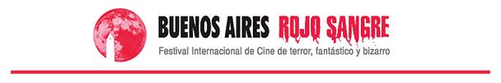

Note to send scanned to materialbars@gmail.com with additional
material requested in the regulations

XX FESTIVAL BUENOS AIRES ROJO SANGRE
Autorization

In my role as Producer/Director of ___________________________________, I authorize the projection of the mentioned film in XX Buenos Aires Rojo Sangre Film Festival, to be held in date to be set between November-December 2019 on Buenos Aires City, Argentina.

Complete name and sign:
______________________________________
Mail:
______________________________________
Telephone:
______________________________________
Date:
______________________________________

